g]kfn ;/sf/
sfg"g, Gofo tyf ;+;bLo dfldnf dGqfnosf]
;"rgf
;/sf/L d'2f ;DaGwL -klxnf] ;+zf]wg_ lgodfjnL, @)&#
;/sf/L d'2f ;DaGwL lgodfjnL, @)%% nfO{ ;+zf]wg ug{ jf~5gLo ePsfn],
;/sf/L d'2f ;DaGwL P]g, @)%% sf] bkmf #^ n] lbPsf] clwsf/ k|of]u u/L g]kfn ;/sf/n] b]xfPsf lgodx? agfPsf]5 .
!= ;+lIfKt gfd / k|f/De M -!_ oL lgodx?sf] gfd æ;/sf/L d'2f ;DaGwL -klxnf] ;+zf]wg_ lgodfjnL, @)&#Æ /x]sf]5 .
-@_ of] lgodfjnL t'?Gt k|f/De x'g]5 .
@= ;/sf/L d'2f ;DaGwL lgodfjnL, @)%% sf] lgod $ df ;+zf]wg M ;/sf/L d'2f ;DaGwL lgodfjnL, @)%% -o; kl5 æd"n lgodfjnLÆ elgPsf]_ sf] lgod $ sf] pklgod -#_ df /x]sf æcfjZostfg';f/ 7f8f] d''r'Nsf v8f ug{' kg{]5Æ eGg] zAbx?sf] ;§f æcg';"rL–#s= adf]lhdsf] 9fFrfdf a/fdbL d'r'Nsf tof/ ug{' kg{]5Æ eGg] zAbx? /flvPsf 5g\ .
#= d"n lgodfjnLdf lgod *s=/ *v=yk M d"n lgodfjnLsf] lgod * kl5 b]xfosf lgod *s= / *v= ylkPsf 5g\ M–
æ*s= zf/Ll/s hfFr M P]gsf] bkmf !@ adf]lhd s'g} JolQmsf] z/L/sf] hfFr ug{] lrlsT;s jf k|of]uzfnfn]] b]xfo adf]lhdsf] 9fFrfdf ;DalGwt k|x/L sfof{nodf k|ltj]bg k7fpg' kg{]5M–
-s_ of}ghGo ck/fwdf zf/Ll/s hfFr u/]sf]df dlxnfsf] eP cg';"rL–!)s= / k'?ifsf] eP cg';"rL–!)v= adf]lhdsf] 9fFrfdf,
-v_ pd]/ hfFr u/]sf]df cg';"rL–!)u= adf]lhdsf] 9fFrfdf,
-u_ dfbs kbfy{ ;]jg ;DaGwL hfFr u/]sf]df cg';"rL–!)3= adf]lhdsf] 9fFrfdf .
*v= j}1flgs jf l8=Pg=P=k/LIf0f M -!_ ck/fw cg';Gwfgsf] l;nl;nfdf j}1flgs jf l8=Pg=P= k/LIf0faf6 ck/fw;Fu dxTjk"0f{ k|df0f pknAw x'g ;S5 eGg] ljZjf; ug{] dgfl;j cfwf/ ePdf txlssft ug{] k|x/L sd{rf/Ln] To:tf] k/LIf0f ug{ ;DalGwt lgsfodf k7fpg ;Sg]5 .
-@_ pklgod -!_ adf]lhd l8=Pg=P= k/LIf0fsf] nflu k7fpg' cl3 k|x/L sd{rf/Ln] l8=Pg=P= gd"gfbftfsf] cg';"rL–!)ª= adf]lhdsf] 9fFrfdf dGh'/gfdf lng' kg{]5 .
-#_ pklgod -!_ adf]lhd j}1flgs jf l8=Pg=P= k/LIf0fsf] nflu k7fOPsf]df To:tf] k/LIf0f ug{] lrlsT;s jf k|of]uzfnfn] j}1flgs k/LIf0f u/]sf]df cg';"rL–!)r= / l8=Pg=P=k/LIf0f u/]sf]df cg;"rL–!)5= adf]lhdsf] 9fFrfdf k/LIf0f k|ltj]bg ;DalGwt k|x/L sfof{nodf k7fpg' kg{]5 .Æ
$= d"n lgodfjnLsf] lgod !) df ;+zf]wg M d"n lgodfjnLsf] lgod !) sf] ;§f b]xfosf] lgod !) /flvPsf]] 5 M–
æ!)= ;gfvt M -!_ P]gsf] bkmf !^ sf] pkbkmf -!_ adf]lhd s'g} cleo'Qmsf] ;gfvt u/fpg' kbf{ cg';"rL–!@s= adf]lhdsf] 9fFrfdf u/fpg' kg{]5 .
-@_ P]gsf] bkmf !^ sf] pkbkmf -@_ adf]lhd s'g} d'2f;Fu ;DalGwt b;L, rLh jf j:t' ;gfvt u/fpg' kbf{ ;gfvt u/fpg' kg]{ ;DalGwt JolQmnfO{ To:tf] b;L, rLh jf j:t' b]vfO{ cg';"rL–!@v= adf]lhdsf] 9fFrfdf ;gfvt u/fpg' kg]{5 .Æ
%= d"n lgodfjnLsf] cg';"rLdf ;+zf]wg M d"n lgodfjnLsf],–
-s_ cg';"rL–# kl5 o;} ;fy ;+nUg cg';"rL–#s= ylkPsf]] 5 .
-v_ cg';"rL–% sf] ;§f o;} ;fy ;+nUg cg';"rL–% /flvPsf] 5 .
-u_ cg';"rL–( / !) sf] ;§f o;} ;fy ;+nUg cg';"rL–( / !) /flvPsf 5g\ .
-3_ cg';"rL–!) kl5 o;} ;fy ;+nUg cg';"rL–!)s=, !)v=, !)u=, !)3=, !)ª=, !)r= / !)5=ylkPsf 5g\ .
-ª_ cg';"rL–!@ kl5 o;} ;fy ;+nUg cg';"rL–!@s= / !@v= ylkPsf 5g\ .
cg';"rL–#s=
-lgod $ sf] pklgod -#_ ;Fu ;DalGwt_
36gf:yndf v8f ul/Psf] a/fdbL d'r'Nsfsf] 9fFrf
>L ====================== k|x/L sfof{no ==================== af6 ====================== ufpF ljsf; ;ldlt÷gu/kflnsf j8f g+= ============== -:yfg_ df v8f ul/Psf] =============== ck/fw;Fu ;DalGwt rLh j:t'÷7fpFsf] a/fdbL d'r'Nsf .
- hfx]/L b/vf:t jf ck/fwsf] ;"rgfsf] 5f]6s/L ljj/0f M
- vfgtnf;L ug{] clwsf/L jf sd{rf/Lsf] clu|d tnf;L lng'kg{] eP ;f] lnPsf] ljj/0f M
- a/fdbL÷vfgtnf;L ul/Psf] rLh j:t'÷7fpFsf] rf/ lsNnf ;lxtsf] ljj/0f M
- a/fdb ePsf] ck/fw;Fu ;DalGwt ;fdfg jf b;Lsf] ljj/0f M
- b]v] adf]lhd b:tvt ug{] ;fIfLx?sf] gfd, y/, jtg, pd]/ b:tvt M
-s_
-v_
-u_
- /f]xj/df a:g]x?sf] gfd, y/, jtg, pd]/ / b:tvt M
-s_ cg';Gwfg clws[tn] 36gf:yndf ck/fw;Fu ;DalGwt rLh j:t', b;Lsf] ;fdfg a/fdb u/L lnPsf] egL b:tvt ug{] =================== lhNnf ================ ufpFljsf; ;ldlt÷gu/kflnsf j8f g+= ================ :yfg a:g] ============================
-v_ hfx]/jfnfsf] gfd, y/, jtg ============== pd]/ ========= b:tvtM ===================
-u_ cleo'Qmsf] gfd, y/, jtg ======================= pd]/ ======= b:tvtM ====================
a/fdbL, vfgtnf;L ;d]tsf] sfd tfd]n ug{ vl6Psf cg';Gwfg clws[t M
cGo sd{rf/Lx? M
- ldlt M
- ;do M
cg';"rL–%
-lgod % ;Fu ;DalGwt_
a/fdbL÷vfgtnf;L d'r'Nsfsf] 9fFrf
>L ====================== k|x/L sfof{no ==================== af6 ====================== ufpFljsf; ;ldlt÷gu/kflnsf j8f g+= ============== -:yfg_ df v8f ul/Psf] =============== ck/fw;Fu ;DalGwt rLh j:t'÷7fpF÷dflg;sf] z/L/sf] a/fdbL÷vfgtnf;L d'r'Nsf .
- hfx]/L b/vf:t jf ck/fwsf] ;"rgfsf] 5f]6s/L ljj/0f M
- vfgtnf;L ug{] clwsf/L jf sd{rf/Lsf] clu|d tnf;L lng'kg{] eP ;f] lnPsf] ljj/0f M
- a/fdbL÷vfgtnf;L ul/Psf] rLh j:t'÷7fpF÷dflg; /x]sf] rf/ lsNnf ;lxtsf] ljj/0f M

- a/fdb ePsf] ck/fw;Fu ;DalGwt ;fdfg jf b;Lsf] ljj/0f M
- b]v] adf]lhd b:tvt ug{] ;fIfLx?sf] gfd, y/, jtg, pd]/ b:tvt M
-s_
-v_
-u_
- /f]xj/df a:g]x?sf] gfd, y/, jtg pd]/ / b:tvt M
-s_ cg';Gwfg clws[tn] d]/f] 3/, rLh j:t', z/L/ vfgtnf;L lnbf cfkm\gf] tnf;L lbO{ OHht;fy d]/f] tnf;L lnPsf] / 3/sf] jf d]/f] s'g} ;fdfg lxgfldgf ePsf] 5}g egL b:tvt ug{] ======================= lhNnf ====================== ufpFljsf; ;ldlt÷gu/kflnsf j8f g+= ================== :yfg a:g] ============================
-v_ hfx]/jfnfsf] gfd, y/, jtg =============== pd]/ ========= b:tvt M =====================
-u_ cleo'Qmsf] gfd, y/, jtg ================== pd]/ ======= b:tvt M ====================

a/fdbL, vfgtnf;L ;d]tsf] sfd tfd]n ug{ vl6Psf cg';Gwfg clws[t M
cGo sd{rf/Lx? M
- ldlt M
- ;do M
cg';"rL–(
-lgod & sf] pklgod -!_ ;Fu ;DalGwt_
zj k/LIf0f k|ltj]bgsf] 9fFrf
AUTOPSY REPORT
1. Case registration number:
2. Police Office sending for autopsy (letter date and reference number):

3. Name of the deceased: 4. Address:
5. Gender: 6. Age, Date of Birth:
7. Dead body identified by:
8. Name of the accompanying Police Personnel:
9. Date and time of death:
10. Date and hour of receipt of inquest papers and dead body:
11. Date and hour of starting autopsy:
12. Date and hour of concluding autopsy:
13. Name of the Experts conducting autopsy:

(1)……………….…. (2) ……….…... (3) ……….. (4) ……….
14. Name of the Hospital:

RELEVANT DETAILS (Mention brief history of the case regarding circumstances of death and other sources of information):

EXTERNAL EXAMINATION (General observation of the dead body):
(1) Height: (2) Weight: (3) Physique: (4) Hairs:
(5) Clothes and conditions:

(6) Special identifying features (Huliya):

(7) Post-mortem changes present:
(a) Rigor mortis:

(b) Livor mortis:

(c) Algor mortis/Cooling:

(d) Different signs of decomposition:

(8) Natural orifices:
Eyes: Mouth: Vagina/penis:
Nose: Ears: Anus:
Urethra:

(9) Injuries: Name, size and site (Ante mortem /post-mortem /old /fresh)

INTERNAL EXAMINATION
Head and Neck:
- Scalp, skull:

- Brain and vessels:

- Orbital, nasal and aural cavities:
- Mouth, tongue:
- Neck (larynx, thyroid and other neck structures) :

- Other relevant details:
Chest (Thorax)

- Ribs and chest wall:
- Diaphragm:
- Oesophagus:
- Trachea and bronchi:
- Pleural cavities:
- Lungs:
- Heart and pericardial sac (any content in pericardial sac, condition of three coronary arteries, valves and chambers and myocardium must be observed):-
Abdomen

- Peritoneal and Pelvic cavity :

- Stomach and content :
- Small intestine:
- Large intestine:
- Liver, gall bladder, pancrease :
- Spleen:
- Kidney, renal pelvis :
- Genital organs:
- Urinary bladder and urethra:
Spinal Column:

Specimen Collected For Analysis (Mention preservative also)
Toxicology
- Stomach with contents:
- Part of liver:
- Kidney:
- Blood:
- Others; if any:
Histopathology :
Others(Specify):

Special Examination (Procedures like neck dissection, pelvic dissection, flotation test of lungs etc. must be done in relevant cases and findings should be documented):
Items Handed Over (when and who received?)
- Autopsy report:-
- Viscera and other Samples :-
- Clothes and other articles:-
Opinion or Conclusion
- Opinion on cause of death: ……………………………………………………………
d[To'sf] sf/0f -g]kfnLdf ;d]t_ M
- Opinion on time since death:
- Opinion on probable type of objects or weapon causing injuries:

- Opinion on live birth or still birth:

- Other Opinion; if any:
Signature of Medical Officer / Expert
- ………….  Signature:  Date:  Name:  Special Qualification,  Training and Experience:  N.M.C. Reg. No.: | 2. …….  Signature:  Date:  Name:  Special Qualification,  Training and Experience:  N.M.C. Reg. No.: | 3. …….  Signature:  Date:  Name:  Special Qualification,  Training and Experience:  N.M.C. Reg. No.:

Seal of the Hospital :
Date :

b|i6Jo M
- zj k/LIf0f sfo{ ;+ej eP;Dd Forensic ljifosf] ljz]if1n] / To:tf] ljz]if1 gePdf tflnd k|fKt lrlsT;sn] ug'{ kb{5 .
- zj k/LIf0f ug]{ ljz]if1 jf lrlsT;sn]g} k|ltj]bg tof/ ug'{ kb{5 .
- ;+ej eP;Dd sDo'6/ 6fOk u/L k|ltj]bg tof/ ug'{ kg]{5, ;f] gePdf :ki6 a'lemg] u/L pNn]v ug'{ kg]{5 . ;fy} k/LIf0f k|ltj]bgsf] ;Ssn k|lt g} ;+nUg ug'{ kg]{5 .
- lgwf{l/t :yfgdf ljj/0f pNn]v ug{ gk'u ePdf 5'§} kfgfdf ;d]t ljj/0f pNn]v ug'{ kg]{5 .

cg';"rL–!)
-lgod & sf] pklgod -@_ ;Fu ;DalGwt_
3fp hfFr s]z kmf/fdsf] 9fFrf
INJURY EXAMINATION REPORT
(IT IS USED IN CASE OF EXAMINATION OF DETAINEE ALSO)

- Case Registration No.:
- Name of the Office referred for injury examination (with letter ref. No. and Date) :
- Name, Age, Date of birth and Sex of the injured person:
- Address:
- Name of the accompanying Police Personnel:
- Name of the Hospital/Health centre:
- Date, time and place of examination:
- Identification mark of the examinee :
- Consent for examination taken from :
Injured person Family member or others
- Brief history about the incident (how and when the injuries were produced?):

- Medical history of the examinee :

- General Physique and vitals :
Height: Weight: Pulse: B.P: Temperature: Respiratory Rate:
Degree of Consciousness:
- Injuries (Name, Size, Site, Color , Surrounding area, Signs of treatment, Bleeding Marks, Sign of Healings, any Imprints and content etc.) :

- Type of injury
a. Simple:
b. . Angabhanga (Grievous) :
c. Severe:
d. Other remarks:
- Type of weapon/object used:
i) Blunt force ii) Sharpe force iii) Pointed objects
iv) Projectile v) Heat vi) Chemical
vii) Others (Specify)
- Condition of the patient at the time of examination :

- Severity (Explain the severity in terms of existing condition and possible complication) :
- Investigation and reports (for example X-ray, USG, Blood, Urine etc) :
- Treatment provided (briefly) :
- Referral (Where and Why?):

- Follow up (if necessary ) :
- Re- Examination (Whether case needs information about grade of disability ) :

Opinion: (Condition of examinee, severity of the injury, age of the injury and possible causative objects should be considered to frame opinion)

Name of the Examiner: Signature:
Qualification:- MC ⁄ NHPC Reg. No. :
Office/Hospital/Health Centre: Date:
Seal of the Hospital/Health Centre:
b|i6Jo M
- 3f hfFr sfo{ ;+ej eP;Dd Forensic ljifosf] ljz]if1n] / To:tf] ljz]if1 gePdf tflnd k|fKt lrlsT;fsdL{n] ug'{ kb{5 .
- 3f hfFr ug]{ ljz]if1 jf lrlsT;fsdL{n]g} k|ltj]bg tof/ ug'{ kb{5 .
- ;+ej eP;Dd sDo'6/ 6fOk u/L k|ltj]bg tof/ ug'{ kg]{5, ;f] gePdf :ki6 a'lemg] u/L pNn]v ug'{ kg]{5 . ;fy} k/LIf0f k|ltj]bgsf] ;Ssn k|lt g} ;+nUg ug'{ kg]{5 .
- lgwf{l/t :yfgdf ljj/0f pNn]v ug{ gk'u ePdf 5'§} kfgfdf ;d]t ljj/0f pNn]v ug'{ kg]{5 .

cg';"rL–!)s=
-lgod *s= sf] v08 -s_ ;Fu ;DalGwt_

of}ghGo ck/fw ;DaGwL zf/Ll/s k/LIf0f k|ltj]bgsf] 9fFrf -dlxnfsf] xsdf_
REPORT OF MEDICAL EXAMINATION IN SEXUAL OFFENCE
(FEMALE SUBJECT)

1. Case Registration No.:
2. Name of the Office referred for examination (with letter reference No. and Date)

3. Name of the accompanying Police Personnel:

DETAIL ABOUT THE EXAMINEE

1. Name/ Code Name (To maintain confidentiality): 2. Age and Sex:
3. Address: 4. Marital status:
5. Guardian′s Name and relation:
6. Date and time of examination:
7. Attendant's Name and address:
8. Identification marks:
9. Consent for examination: I am fully aware about the process and possible consequences of the examination; I hereby give my full consent for medical examination without any compulsion. (Consent should be taken in the form of signature ⁄ thumb print.) For minors Consent should be taken from guardians.
10. Brief History of the incident, as stated by examinee or guardian (How, When, Where and what had happened?):
11. Medical history (Emotional, Medical and Psychological history including past medical history):
12. Clothes changed or not after incident:
13. Whether clothes and body parts washed or not after the incident:
14. Description of the examination of clothes (Any tear, scratches, stain and foreign materials :
EXAMINATION
1. General physique and vitals:-
Height: Weight: Pulse: B.P:
Temperature: Respiratory rate: Degree of consciousness:
Any disability:
2. Injuries on the bodies (Name, Size, Site, Color, Surrounding area, Sign of treatment, Bleeding Marks, Sign of Healings, any Imprints etc.) Please use the figure provided to depict the injuries as best as possible:-

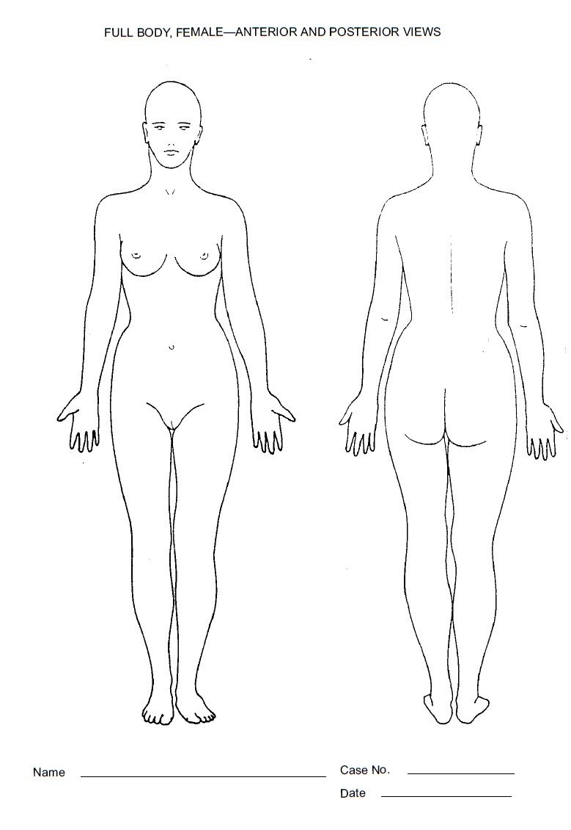

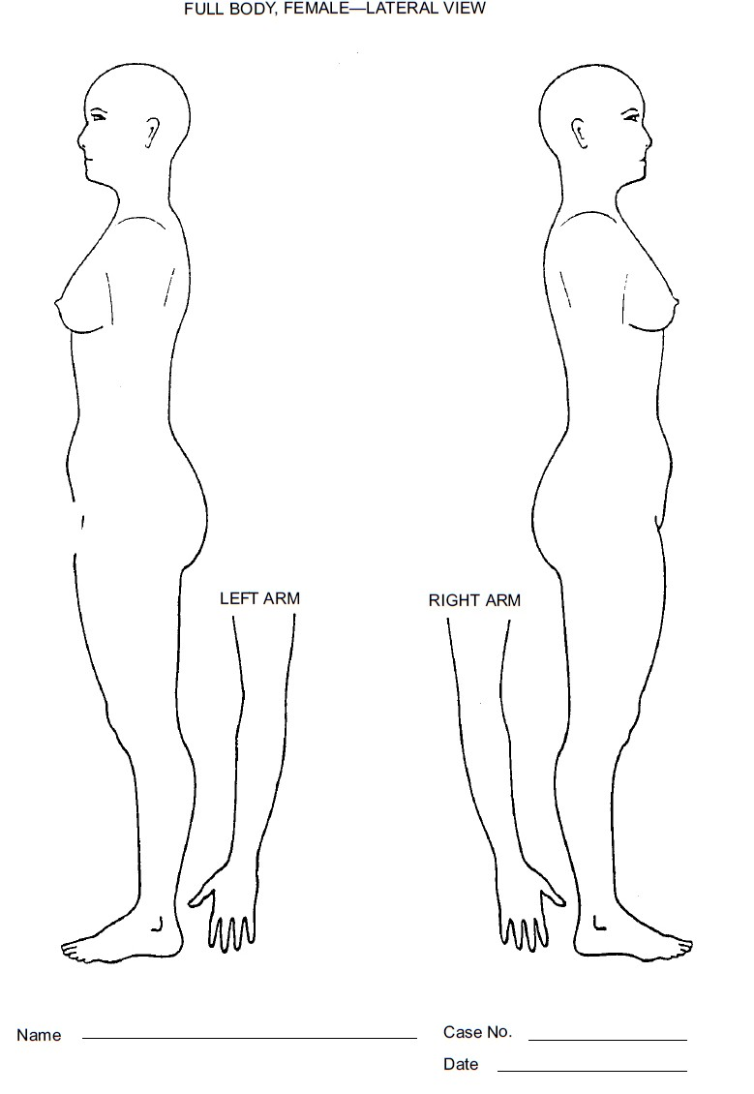

3. Genital injuries (Name, Size, Site, Color, Surrounding area, Sign of treatment, Bleeding Marks, Sign of Healings, Imprints, any content, stain and discharge etc.) Please use the figure provided to depict the injuries as best as possible:-
- Perineum :
- Vulva:
(c) Vagina:
(d) Hymen:
(e) Perianal area and anal orifice:
(f) Oral cavity:
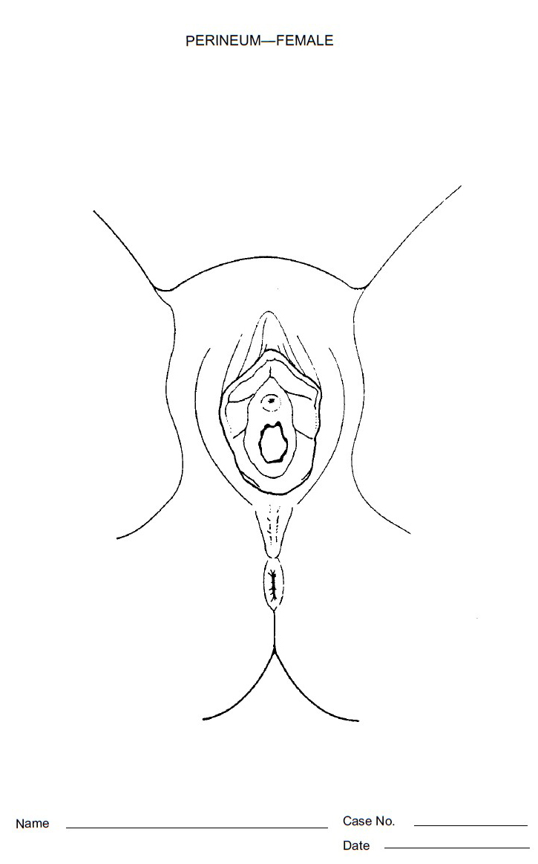
4. Conditions of pubic hair (Matted, stained, any foreign hairs) :
5. Bite marks: (enclose photos if possible)
6. Specimen preserved for further analysis:
(a) Blood (Alcohol, Drug, Grouping, DNA, HIV AIDS, VDRL, HBS-Ag, TPHA)
(b) Urine (Intoxication/pregnancy) (c) swab from stains
(d)Vaginal swab (e) Foreign hairs ⁄ debris
(f) Hair from the examinee (g) Nail scrapings
(h) Others:
7. Investigation and reports:
8. Treatment (including prevention of pregnancy, vaccination and sexually transmitted diseases):
9. Referral (Where and Why?):
10. Follow up visits suggested on :
11. Psychiatric evaluation and psychosocial counseling:
12. Condition of teeth (Type of dentition and Number of teeth) :
8 7 6 5 4 3 2 1 ⁄ 1 2 3 4 5 6 7 8
……………………………… ═ ( Total teeth)
8 7 6 5 4 3 2 1 ⁄ 1 2 3 4 5 6 7 8

Opinion of the expert:(while framing opinion the examiner should analyze her mental status, possible causation of injuries and their time of infliction, age estimation in case of minors or teenagers and general condition of the examinee. If there are signs of alleged sexual activities mentioned in history also should be considered while framing opinion. In case of complete negative findings in examinee, the examiner cannot declare that the alleged incident did not take place).
(a) Opinion about mental status of the examinee:
(b) Opinion about the injuries on body:
(c) Opinion about the condition of genital organs:
(d) Opinion about age of the Examinee:
(e) Other opinion, if any :

Name of the Examiner:
Signature: Qualification:
NMC ⁄ NHPC Reg. No. : Office/Hospital/Health Centre:
Date:- Seal of the Hospital/Health Centre: b|i6Jo M
- k/LIf0f sfo{ ;+ej eP;Dd Forensic ljifosf] ljz]if1n] / To:tf] ljz]if1 gePdf tflnd k|fKt lrlsT;fsdL{n] ug'{ kb{5 .
- k/LIf0f ug]{ ljif]z1 jf lrlsT;fsdL{n]g} k|ltj]bg tof/ ug'{ kb{5 .
- ;+ej eP;Dd sDo'6/ 6fOk u/L k|ltj]bg tof/ ug'{ kg]{5, ;f] gePdf :ki6 a'lemg] u/L pNn]v ug'{ kg]{5 . ;fy} k/LIf0f k|ltj]bgsf] ;Ssn k|lt g} ;+nUg ug'{ kg]{5 .
- lgwf{l/t :yfgdf ljj/0f pNn]v ug{ gk'u ePdf 5'§} kfgfdf ;d]t ljj/0f pNn]v ug'{ kg]{5 .

cg';"rL–!)v=
-lgod *s= sf] v08 -s_ ;Fu ;DalGwt_
of}ghGo ck/fw ;DaGwL zf/Ll/s k/LIf0f k|ltj]bgsf] 9fFrf -k'?ifsf] xsdf_
REPORT OF MEDICAL EXAMINATION OF MALE SUBJECT IN SEXUAL OFFENCES

1. Case Registration No.:
2. Name of the Office referred for examination (with letter reference No. and Date)
3. Name of the Accompanying Police Personnel:
DETAIL ABOUT THE EXAMINEE
=
1. Name/ Code Name (To maintain confidentiality): 2. Age and Sex:
3. Address: 4. Marital Status:
5. Guardian′s Name and Relation:
6. Date and Time of Examination:
7. Attendant's Name ⁄ Address:
8. Identification Marks :
9. Consent for examination: I am fully aware about the process and possible consequences of the examination; I hereby give my full consent for medical examination without any compulsion. (Consent taken in the form of signature ⁄ thumb print.) For minors Consent taken from guardians .
10. Brief History of the incident (How, When, Where and what had happened?):

11. Medical History (Emotional, Medical and Psychological history including past medical history):
12. Clothes changed or not after incident:
13. Whether clothes and body parts washed or not after the incident:
14. Description of the examination of clothes (Any tear, scratches, stain and foreign materials :
EXAMINATION
1. General Physique and vitals:
Height: Weight: Pulse: B.P:
Temperature: Respiratory Rate: Degree of Consciousness:
Any disability:
2. Injuries on the bodies (Name, Size, Site, color, Surrounding area, Sign of treatment, bleeding Marks, Sign of Healings, any Imprints etc.) :

3. Genital injuries (Name, Size, Site, color , Surrounding area, Sign of treatment, Bleeding
Marks, Sign of Healings, imprints, any stain and discharge etc.) :
(a) Perineum:
(b) Penis:
(c) Scrotum:
(d) Perianal area and anal orifice:
(e) Oral cavity:
4. Conditions of pubic hair (Matted, Stained, Any foreign hairs) :
5. Bite Marks:- (Enclose photos if possible)
6. Specimen Preserved for further analysis:
(a) Blood (Alcohol, Drug, Grouping, DNA, HIV, VDRL, HBS-Ag, TPHA)
(b) Urine. (c) Swab from stains. (d) Swab from penis (e) Foreign hairs ⁄ debris
(f) Hair from the Examinee. (g) Nail scrapings.
(h) Others (including oral sexual activities) :

7. Investigation and reports:
8. Treatment (including sexually transmitted diseases):
9. Referral (Where and Why?):
10. Follow up (if necessary):
11. Psychiatric evaluation and psychosocial counseling:
12. Condition of teeth (Type of dentition and Number of teeth to assess age of examinee)
8 7 6 5 4 3 2 1 ⁄ 1 2 3 4 5 6 7 8
……………………………… ═ ( Total teeth)
8 7 6 5 4 3 2 1 ⁄ 1 2 3 4 5 6 7 8
13. Opinion of the expert:
(a) Opinion about injuries on body:
(b) Opinion about condition of genital organs:
(c) Opinion about the age of the examinee:
(d) Other opinion; if any:
Name of the Examiner:
Signature: Qualification:
NMC ⁄ NHPC Reg. No.: Office/Hospital/Health Centre:
Date: Seal of the Hospital/Health Centre:
b|i6Jo M
- k/LIf0f sfo{ ;+ej eP;Dd Forensic ljifosf] ljz]if1n] / To:tf] ljz]if1 gePdf tflnd k|fKt lrlsT;fsdL{n] ug'{ kb{5 .
- k/LIf0f ug]{ ljz]if jf lrlsT;fsdL{n]g} k|ltj]bg tof/ ug'{ kb{5 .
- ;+ej eP;Dd sDo'6/ 6fOk u/L k|ltj]bg tof/ ug'{ kg]{5, ;f] gePdf :ki6 a'lemg] u/L pNn]v ug'{ kg]{5 . ;fy} k/LIf0f k|ltj]bgsf] ;Ssn k|lt g} ;+nUg ug'{ kg]{5 .
- lgwf{l/t :yfgdf ljj/0f pNn]v ug{ gk'u ePdf 5'§} kfgfdf ;d]t ljj/0f pNn]v ug'{ kg]{5 .

cg';"rL–!)u=
-lgod *s= sf] v08 -v_ ;Fu ;DalGwt_
pd]/ hfFr ;DaGwL zf/Ll/s k/LIf0f k|ltj]bgsf] 9fFrf
REPORT OF MEDICAL EXAMINATION
(AGE ESTIMATION)
1. Case Registration No.:
2. Name of the Office referred for examination (with letter reference No. and Date)

3. Name of the accompanying Police Personnel or other:
DETAILS ABOUT THE EXAMINEE
1. Name ⁄ Code Name (For the purpose of maintaining confidentiality):
2. Alleged Age and Sex:
3. Address:
4. Identification marks (Huliya):
5. Brought by and identified by:
6. Date, time and place of examination:
7. Consent: I am fully aware about the procedure and possible consequences of the examination; I hereby give my full consent for medical examination without any compulsion. (Consent should be taken in the form of signature ⁄ thumb print. In case of minors consent shall be taken from guardians.)
From the examinee: From other guardian:

GENERAL PHYSIQUE AND DEVELOPMENT
1. Height: 2. Weight:
3. Voice (Adult/Child type):
4. Adam’s apple
5. Scalp hair (Colour, length):
6. Moustaches (Present/absent; colour, length, distribution):
7. Beards (Present/Absent; colour, length, distribution) :
8. Auxiliary hairs (Present/absent; colour, length, distribution):
9. Pubic hairs (Present /absent; colour, length, distribution):.
10. Any abnormality and disease (If present to be described):
11. Breast Development (Globular/Pendular; nipple and areola colour):
12. Menstruation; when started:
13. Mental state (Alert/ not alert):
14. Dental development (Type of dentition; temporary/mixed/permanent and Number of teeth):
8 7 6 5 4 3 2 1 / 1 2 3 4 5 6 7 8
………….……………............... = (Total teeth)
8 7 6 5 4 3 2 1 / 1 2 3 4 5 6 7 8
15. X-ray examination:
(a) Right elbow A/P & lateral views:
- Lateral epicondyle is (completed/not completed/not started) to fuse.
- Medial epicondyle is (completed/ not completed/not started) to fuse
- Upper end of radius is(completed/not completed/not started)to fuse.
- Olecranon is (completed/ not completed/not started)to fuse

(b) Right wrist with hand A/P view:
- Lower end of radius is (completed/not completed/not started) to fuse.
- Lower end of ulna is (completed/not completed/not started)to fuse.
- Base of first metacarpal is (completed/not completed/not started) to fuse.
- Heads of metacarpals are (completed/not completed/not started) to fuse.
- Pisi form bone is (ossified/ not ossified.
- Phalanges are (completed/not completed/not started)to fuse

(c) Pelvis A/P view:
- Heads of femur are (completed/not completed/not started) to fuse
- Greater and lesser trochanters are (completed/not completed/not started) to fuse.
- Triradiate cartilages are visible/invisible in acetabular fossa.
- Iliac creasts are (completed/not completed/not started) to fuse.
- Ischial tuberosities are (completed/not completed/not started) to fuse.
(d) Other parts of the body:
X-ray taken in (Hospital): Date:
X-ray code or Number in plates:
OPINION:

The examinee is in between …. year and …. Year.

Name of the Examiner:
Signature: Qualification:
NMCReg. No. : Office/Hospital/Health Centre:
Date: Seal of the Hospital/Health Centre:
b|i6Jo M
- k/LIf0f sfo{ ;+ej eP;Dd Forensic ljifosf] ljz]if1n] / To:tf] ljz]if1 gePdf tflnd k|fKt lrlsT;fsdL{n] ug'{ kb{5 .
- k/LIf0f ug]{ ljz]if1 jf lrlsT;fsdL{n]g} k|ltj]bg tof/ ug'{ kb{5 .
- ;+ej eP;Dd sDo'6/ 6fOk u/L k|ltj]bg tof/ ug'{ kg]{5, ;f] gePdf :ki6 a'lemg] u/L pNn]v ug'{ kg]{5 . ;fy} k/LIf0f k|ltj]bgsf] ;Ssn k|lt g} ;+nUg ug'{ kg]{5 .
- lgwf{l/t :yfgdf ljj/0f pNn]v ug{ gk'u ePdf 5'§} kfgfdf ;d]t ljj/0f pNn]v ug'{ kg]{5 .

cg';"rL–!)3=
-lgod *s= sf] v08 -u_ ;Fu ;DalGwt_
dfbs kbfy{ ;]jg hf+r ;DaGwL zf/Ll/s k/LIf0f k|ltj]bgsf] 9fFrf
REPORT OF DRUNKENNESS EXAMINATION
(Including cases of drug intoxication)
1. Case Registration No.:
2. Name of the Office referred for examination (with letter reference No. and Date)

3. Name of the accompanying Police Personnel:
DETAIL ABOUT THE EXAMINEE
1. Name of the Examinee : 2. Age and sex
3. Address:
4. Identification marks (Huliya): …
5. Brought by and identified by:
6. Date and time of examination:
7. Examination place:
8. Examinee restrained on arrival: yes / no;
9. Expressed consent for examination:
10. Persons present during examination (Name and position):
11. Brief history of the case (In the language of examinee if possible including the habit of the examinee; regular drinker/casual drinker/non drinker):
12. Any medicine or recreational drugs taken?:
13. Past medical history:
EXAMINATION AND FINDINGS
General physique and vitals
1. Height: 2. Weight: 3. Blood pressure:
4. Pulse rate: 5. Breathe (any smell): 6. Respiration rate:
7. Gait: 8. Stance: 9. Speech:
10. Consciousness:
11. Orientation to time, place and person:
12. Reflexes:
13. Visual acuity:
14. Muscles coordination tests:
- Finger to finger test: can /cannot perform/performs with difficulty.
- Finger nose test: can/cannot perform/performs with difficulty.
- Buttoning/unbuttoning cloth: can/cannot perform/performs with difficulty.
- Picking small objects from surfaces: can/cannot perform/performs with difficulty.
- Walking on straight line: can/cannot walk.
- Writing: normally in straight line/incoherent.
15. Condition of the clothes (Any stains, tears, scratches, buttons off etc):
16. Injuries; if any (Nature, site, size of injuries):

17. Mental state assessment: Mentally alert or not? Whether s/he needs mental state examination?

18. Blood analysis for alcohol level (5ml from vein in NaF preservative): Yes /no
19. Urine for alcohol: yes/no
(Report of laboratory analysis): To be added after test completed
20. Acute health needs found:
21. Treatment provided:
22. Referral; if necessary (where and why?):
OPINION: (Mark any one of the following)
- The examinee has not consumed alcohol
- The examinee has consumed alcohol but not under influences of it.
- The examinee has consumed alcohol and under influences of it.
- The examinee needs treatment in hospital for intoxication by alcoholic drink.
- Any other remarks:
Name of the Examiner:-
Signature:- Qualification:-
NMC ⁄ NHPC Reg. No.:- Office/Hospital/Health Centre:-
Date:- Seal of the Hospital/Health Centre:-
b|i6Jo M
- k/LIf0f sfo{ ;+ej eP;Dd Forensic ljifosf] ljz]if1n] / To:tf] ljz]if1 gePdf tflnd k|fKt lrlsT;fsdL{n] ug'{ kb{5 .
- k/LIf0f ug]{ ljz]if1 jf lrlsT;fsdL{n]g} k|ltj]bg tof/ ug'{ kb{5 .
- ;+ej eP;Dd sDo'6/ 6fOk u/L k|ltj]bg tof/ ug'{ kg]{5, ;f] gePdf :ki6 j'lemg] u/L pNn]v ug'{ kg]{5 . ;fy} k/LIf0f k|ltj]bgsf] ;Ssn k|lt g} ;+nUg ug'{ kg]{5 .
- lgwf{l/t :yfgdf ljj/0f pNn]v ug{ gk'u ePdf 5'§} kfgfdf ;d]t ljj/0f pNn]v ug'{ kg]{5 .
cg';"rL–!)ª=
-lgod *v= sf] pklgod -@_ ;Fu ;DalGwt_

8L=Pg=P= gd'gfbftfsf] dGh'/gfdf kmf/fdsf] 9fFrf
kf;kf]6{ ;fOhsf] kmf]6f] 6fF;L kmf/d / kmf]6f]df kg]{ u/L b:tvt jf cf}+7f5fk nufpg]

!= 8L=Pg=P= gd"gf bftfsf] ljj/0f M
-s_ k"/f gfd M -v_ hGd ldlt M
-u_ lnË M -3_ hft M -ª_ /fli6«otf M
-r_ 7]ufgf M-lhNnf, ufpFljsf; ;ldlt÷gu/kflnsf, j8f g+=, 6f]n, 3/ g+= cfbL ;d]t _
:yfoL M
c:yfoL M
-5_ kmf]6f] ;lxtsf] kl/ro v'Ng] sfuhM-gDa/, hf/L ldlt / sfof{no ;d]t pNn]v ug]{_
-h_ cl:ydHhf (Bone marrow) jf ljut tLg dlxgfleq c?af6 /ut lnPsf]÷glnPsf] M
@= 8L=Pg=P= k/LIf0f ug]{ JolQm jf lghsf] cleefjs -gd"gfbftf !^ jif{ k"/f gu/]sf] eP_ sf] dGh'/gfdf M
>L ================================sf] 5f]/f÷5f]/L d >L =========================================n] o; ======================= k|of]uzfnfdf 8L=Pg=P=k/LIf0fsf] nflu d]/f]÷d]/f] gftfsf] JolQmsf] /ut÷Øfn /fhLv'zLn] lbb} cfjZos 8L=Pg=P=tYof+ÍLo ljZn]if0f tyf hg;+Vof 8f6fa]; k|of]hg ;d]tsf nflu eljiodf ;f] k|of]u ug{ ;Sg] u/L dGh'/L k|bfg ub{5' . /ut÷Øfn gd'gf d]/f]÷d]/f] ========= gftfsf] JolQmsf]] xf] / d}n] dfly e/]sf] ;Dk"0f{ ljj/0f 7Ls ;fFrf] 5 .
b:tvt cf}+7f 5fk
ldltM bfof+ jf+of
#= gd'gfsf] ljj/0f M ===============
$= /f]xj/ M pNn]lvt JolQmsf] 8L=Pg=P= k/LIf0f gd'gf d]/f] pkl:yltdf ;+sng ul/Psf] xf] .
-s_ gfd, y/, 7]ufgf / pd]/ M
b:tvt M
-v_ gfd, y/, 7]ufgf / pd]/ M
b:tvt M
-u_ gfd, y/, 7]ufgf / pd]/ M
b:tvt M
%= gd"gf lgsfNg] sd{rf/Lsf] ljj/0f
gfd y/ / kb M
b:tvt M
of]Uotf M kl/rokq gDa/ M

k|of]uzfnf k|of]hgsf nflu dfq M
s]z gDa/ M s]zsf] ljj/0f M
s]z k7fpg]sf] gfdM k|fKt kqsf] r=g+= / ldlt M
k|flKt ldlt M gd"gf gDa/ M
cflwsfl/s JolQm M
cGoM
cg';"rL–!)r=
-lgod *v= sf] pklgod -#_ ;Fu ;DalGwt_
j}1flgs k/LIf0f k|ltj]bgsf] 9fFrf
FORENSIC EXAMINATION REPORT

Lab Case No : Date :
Sender (Referred by) : Carried by (Name and Designation) :
Date : Letter No. Ref. No.
Received Date : Numbers of Sample:
Case No: Seal:

Description of Exhibit:
Method of Examination:
Result of Examination:

Expert opinion:

Above analysis is done by me/us. To the best of my/our knowledge the report is true and correct.
Examiner:
Signature: Signature: Signature:
Name: Name: Name:
Qualification: Qualification: Qualification:
Position : Position: Position:
Office: Office: Office:

Date: Seal of the Office:
b|i6Jo M
- k/LIf0f sfo{ ;+ej eP;Dd Forensic ljifosf] ljz]if1n] / To:tf] ljz]if1 gePdf tflnd k|fKt lj1n] ug'{ kb{5 .
- k/LIf0f ug]{ ljz]if1 jf lj1n]g} k|ltj]bg tof/ ug'{ kb{5 .
- ;+ej eP;Dd sDo'6/ 6fOk u/L k|ltj]bg tof/ ug'{ kg]{5, ;f] gePdf :ki6 a'lemg] u/L pNn]v ug'{ kg]{5 . ;fy} k/LIf0f k|ltj]bgsf] ;Ssn k|lt g} ;+nUg ug'{ kg]{5 .
- lgwf{l/t :yfgdf ljj/0f pNn]v ug{ gk'u ePdf 5'§} kfgfdf ;d]t ljj/0f pNn]v ug'{ kg]{5 .
s[kof o; ;DaGwdf yk kqfrf/ ubf{ / cbfntleq x'g] sfdsf/afxLdf dflysf] d'2f gDa/ pNn]v ug{' xf]nf .
cg';"rL–!)5=
-lgod *v= sf] pklgod -#_ ;Fu ;DalGwt_
l8=Pg=P= k/LIf0f k|ltj]bgsf] 9fFrf

DNA EXAMINATION REPORT

Lab Case No : Date :

Sender : Carried by :
Date : Letter No. Ref. No.
Received Date : Number of Samples:
Case No: Seal :
DNA gd"gf bftfsf] AolQmut ljj/0fM
Description of Exhibit:
Expressed consent for examination:
Method of Examination:
Result of Examination:
Expert opinion:
Above analysis is done by me/us. To the best of my/our knowledge the report is true and correct.
Examiner:
Signature: Signature: Signature:
Name: Name: Name:
Qualification: Qualification: Qualification:
Position: Position.: Position:
Office: Office: Office:

Date: Seal of the Office:
b|i6Jo M
- k/LIf0f sfo{ ;+ej eP;Dd Forensic ljifosf] ljz]if1n] / To:tf] ljz]if1 gePdf tflnd k|fKt lj1n]] ug'{ kb{5 .
- k/LIf0f ug]{ ljz]if1 jf lj1n]g} k|ltj]bg tof/ ug'{ kb{5 .
- ;+ej eP;Dd sDo'6/ 6fOk u/L k|ltj]bg tof/ ug'{ kg]{5, ;f] gePdf :ki6 j'lemg] u/L pNn]v ug'{ kg]{5 . ;fy} k/LIf0f k|ltj]bgsf] ;Ssn k|lt g} ;+nUg ug'{ kg]{5 .
- lgwf{l/t :yfgdf ljj/0f pNn]v ug{ gk'u ePdf 5'§} kfgfdf ;d]t ljj/0f pNn]v ug'{ kg]{5 .
s[kof o; ;DaGwdf yk kqfrf/ ubf{ / cbfntleq x'g] sfdsf/afxLdf dflysf] d'2f gDa/ pNn]v ug{' xf]nf .
cg';"rL–!@s=
-lgod !) sf] pklgod -!_ ;Fu ;DalGwt_
cleo'Qmsf] ;gfvt d'r'Nsfsf] 9fFrf
=============== k|x/L sfof{noaf6 v8f u/]sf] cleo'Qmsf] ;gfvt d'r'Nsf
>L =================================== sf] 5f]/f÷5f]/L ================== lhNnf ======================== ufpFljsf; ;ldlt÷gu/kflnsf j8f g+= ============== a:g] jif{ =========== sf] ===================================== cfu] ldlt ========================== df ======================== ufpFljsf; ;ldlt ÷gu/kflnsf j8f g+= ========= df ============================== d'2f;Fu ;DalGwt ck/fw x'Fbfsf cj:yf÷;f] :yfgdf d pkl:yt /x]sf]÷36gfaf6 kLl8t ePsf]n] s;"/ ug{] JolQmnfO{ sfg"g adf]lhd ;gfvt ug{ ======================= k|x/L sfof{no ======================== af6 dnfO{ pkl:yt u/fOPsf]df hfx]/L b/vf:t nufotsf ;+slnt ldl;n sfuhft k9L afrL ;'gfpFbf ;'g], d]/f] lrQ a'em\of] . sfg"g adf]lhd ;gfvt u/fpg pkl:yt u/fOPsf kfFr hgf JolQm dWo] afofFaf6 qmdzM ====================== g+= df /x]sf b]xfosf JolQmnfO{ ;f] 36gf 36\bfsf avt d}n] b]v]sf] / lghsf] zf/Ll/s agfj6, ?k /+u / cfs[ltaf6 lrg]sf]n] lgh ;f]xL JolQm xf] egL ;gfvt u/L lbPsf] 5'÷lghnfO{ ;f] jf/bft x'Fbfsf avt d}n] gb]v]sf] / lghsf] zf/Ll/s agfj6, ?k /+u / cfs[lt ;d]t km/s k/]sf] x'Fbf lgh ;f] JolQm xf] egL ;gfvt ug{ g;s]sf]÷Joxf]/fsf] d'r'Nsf ul/lbPsf] 5' .
;gfvt ug{] JolQmsf] gfd, y/ jtg, pd]/ / b:tvt M
;gfvt u/fOPsf] :yfg M
d]/f] ;fd'Gg] cfh ldlt ====================== df lgh ============================ n] dnfO{ ==================== k|x/L sfof{nodf ;gfvt u/]sf] 7Ls ;fFrf] xf] egL b:tvt ug{] ;gfvt ul/Psf] JolQmsf] gfd, y/, jtg, pd]/ / b:tvt M–
/f]xj/ M hfx]/jfnf M k|ltjfbL M
;gfvt u/fpg] cg';Gwfg clws[tsf] gfd, y/, bhf{ / b:tvt M–
;gfvt u/]sf] ldltM–
cg';"rL–!@v=
-lgod !) sf] pklgod -@_ ;Fu ;DalGwt_

b;L ;gfvt u/fpg] d'r'Nsfsf] 9fFrf

>L ==================== ====== k|x/L sfof{no =============== af6 af6 v8f ePsf] b;L ;gfvt d'r'Nsf

>L ===================================== sf] 5f]/f÷5f]/L ================== lhNnf ============================== ufpF ljsf; ;ldlt÷gu/kflnsf j8f g+= ============== a:g] jif{ =========== sf] ===================================== cfu] ========================== sf] hfx]/Ln] jfbL g]kfn ;/sf/ k|ltjfbL ======================== ePsf] ============================== d'2fdf 36gf:yn ==================== df km]nf k/]sf]÷ ========================== :yfgdf÷============================ z/L/ tnf;L lnbf km]nf k/]sf]÷k|ltjfbLn] ck/fw ubf{ k|of]u u/]sf] ck/fw;Fu ;DalGwt b]xfosf] rLh j:t' jf b;L cg';Gwfg clws[taf6 cfh dnfO{ b]vfpFbf b]v]+, klxrfg u/L ;gfvt ;d]t u/]+ . pQm rLh j:t' jf b;L d}n] ck/fw ubf{sf cj:yfdf k|of]u u/]sf]÷cg';Gwfg clws[taf6 vfg tnf;L lnbf km]nf k/L a/fdb e} cfPsf] rLh j:t' jf ========================== b;L xf] egL ;gfvt ul/lbPsf] 5' km/s 5}g, km/s 7x/] sfg"g adf]lhd ;x'Fnf a'emfpFnf egL of] ;gfvt d'r'Nsf ul/lbPsf] 5' .
;gfvt ug{] JolQmsf] gfd, y/, jtg ======================= pd]/ ========= b:tvtM ===================== ;gfvt u/]sf] rLh j:t'÷:yfg÷b;Lsf] ljj/0fM
;gfvt u/fOPsf] :yfg M
/f]xj/df a:g]sf] b:tvt
-s_ d]/f] ;fd'Gg] =========================== n] cfh ldlt ===================== df ================= sfof{no ======================== df pko{'Qm rLh j:t' jf b;L ;gfvt u/]sf] 7Ls ;fFrf] xf] egL b:tvt ug{] ================= lhNnf ================== uf=lj=;=÷gu/kflnsf j8f g+= =================== :yfg a:g] jif{============ sf] hfx]/jfnf÷k|ltjfbL =================================
-v_ ===================================================
-u_ ====================================================
;gfvt u/fpg] cg';Gwfg clws[tsf] gfd, y/, bhf{ / b:tvtM
;gfvt u/]sf] ldltM

cf1fn],

6]sk|;fb 9'Ëfgf
g]kfn ;/sf/sf] ;lrj

