
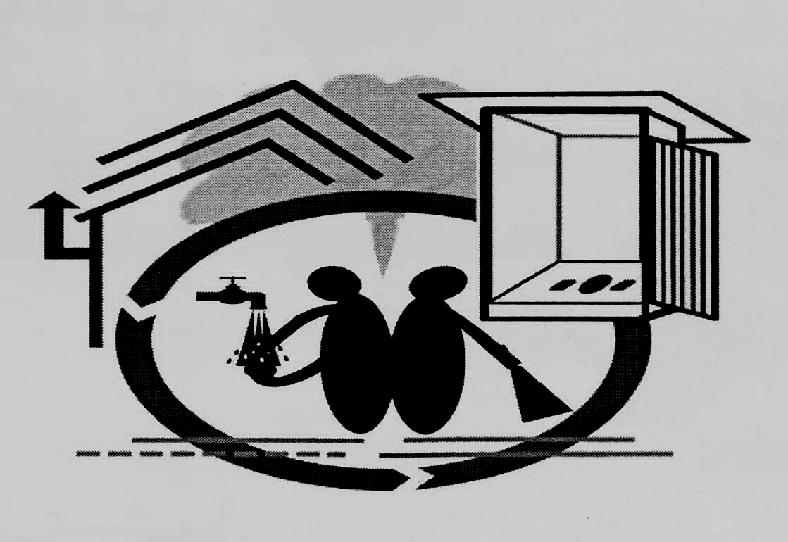
g]kfn ;/sf/
;ª\3Lo dfldnf tyf :yfgLo ljsf; dGqfno
lhNnf ljsf; ;ldltsf] sfof{no
Onfd

k=;+=- _)&@÷&#
r=g+= ldltM– @)&@÷!)÷!#

ul/j;+Fu ljZj]Zj/ sfo{qmd ;fdflhs kl/rfns ljj/0f
qm=;+= | sfo{If]q | ;fdflhs kl/rfns gfdy/ | of]Uotf | nlIft kl/jf/ | ;d"x | ;fd'lxs art | s}lkmot
! | kmfskmf]s | ltn?kf /fO{ | Pd\ P | !@@ | ( j6f | ?= !),))).–
@ | kz'ltgu/ | b'uf{ s'df/ s7]t | P;\ Pn\ l;= | &) | * j6f | – | art ;'? x'Fb}
# | r'nfr'nL | lgd{nf l3ld/] | cfO{= P8\ | !$( | !$ j6f | ?= !@,))).–
$ | dfa' | /rgf /fO{ | cfO{= P8\ | !#% | ( j6f | – | art ;'? x'Fb}
% | ;dfna'ª | d'gfb]jL >]i7 | P;\ Pn\ l;= | !^% | ( j6f | – | art ;'? x'Fb}
^ | ;fskmf/f | z'lznf sfsL{ | P;\ Pn\ l;= | @@% | !@ j6f | – | art ;'? x'Fb}
& | lhd{n] | cGhgf tfdfª -/fO{_ | P;\ Pn= l;= | !@) | ( j6f | – | art ;'? x'Fb}
* | KofË | k|]d s'df/L du/ | P;\ Pn\ l;= | !@@ | ( j6f | – | art ;'? x'Fb}
( | OefË | – | – | – | – | – | If]q 5gf}6 eO{ ;fdflhs kl/rfns lgo'lQm k|lqmofdf

w|'j /fO{
;dGostf{
ul/j;+Fu ljZj]Zj/ sfo{qmd
lh=lj=;= Onfd

