**Nepal Multiple Indicator Cluster Survey - 2019 (MICS6)**

**Press Release**

Today 8th July, 2020,Wednasday, Central Bureau of Statistics has released the Key findings of Nepal Multiple Indicator Cluster Survey 2019 (NMICS 2019).The report is made available through on CBS website [www.cbs.gov.np](http://www.cbs.gov.np).

The NMICS 2019 was conducted by the Central Bureau of Statistics from May to November 2019 as a part of sixth round of the global MICS household programme, with the technical and financial support from United Nations Children’s Fund (UNICEF) Nepal.

NMICS 2019 is a national survey of 12,800 households sample, of which 14,805 women aged 15-49, 5,501 men aged 15-49, 6,658 mothers/caretakers of children under-five years, and 7,792 mothers/caretakers of children 5-17 years were interviewed. In addition, water quality testing for *E.coli* and arsenic was performed in 2,536 households.

NMICS 2019 provides valuable information and the latest evidence on the situation of children and women in Nepal. It provides about 30 Sustainable Development Goals indicators (SDGIs). The survey provides the disaggregated data by province, sex and other characteristics.

The findings of the survey will be used to establish Multidimension Poverty Index (MPI) 2020,monitor 15th Five Year Development Plan (2019/20-2023/24) of Government of Nepal and will also contribute to the voluntary national report (VNR) as well as UN Secretary-General’s report to UN general assembly on the achievements of Sustainable Development Goals.

**Key Findings of NMICS 2019**

**Child mortality**

* Over the period of last five years,2014-2019, the infant mortality rate in Nepal has decreased from 33 to 25 (deaths per 1,000 live births), and the under-five mortality rate has also significantly declined for the same period from 38 to 28. Similarly, the neonatal mortality rate also declined from 23 to 16. (Figure 1)

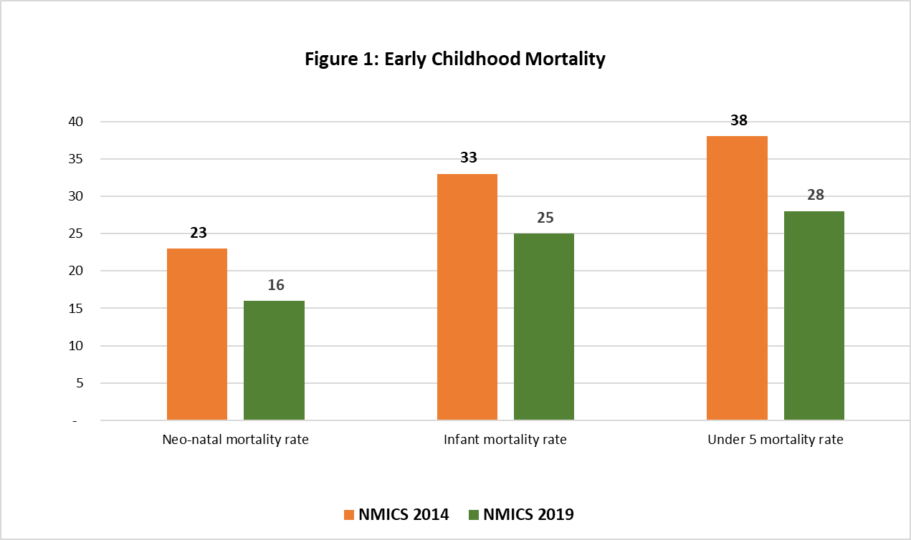

While comparing at provincial level, Sudoorpashchim Province has reported the highest neonatal mortality rate of 25 deaths while Bagmati Province has reported the lowest, 9 deaths. Similarly, Province 5 has reported the highest Infant mortality rate of 35 deaths and the lowest is reported in Province 2, 15 deaths. Province 5 has also reported the highest Under-five mortality rate of 40 deaths while Province 2 and Bagmati Province has reported lowest 19 deaths.(Figure 2)

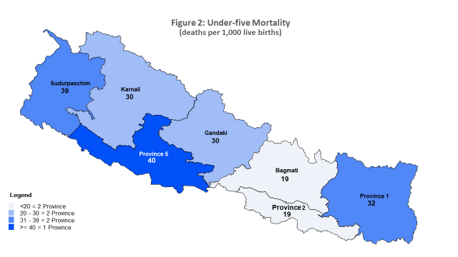

**Access to electricity and telephone**

* 89.9% of household members have access to electricity in Nepal. Gandaki Province reported the highest of 98.9%, while Karnali Province reported the lowest of 44.9%.
* Nationwide, 96.2% of households have a telephone (fixed line or mobile phone) while that of Bagmati province was reported the highest (98.0%) and the lowest (93.6%) in Karnali province.

**Access to mass media and use of information/communication technology**

* 4.1% of women aged 15–49 years who, at least once a week, read a newspaper or magazine, listen to the radio, and watch television as compared to 12.9% of men of the same age.
* One out of every two (51.1%) household have reported to have access to internet by any device, which indicates the significant use of internet at home.

## Among the women age 15- 49 years, 79.3% reported that they own a mobile phone and 92.4% reported using it during the last 3 months. Similarly, among men of age 15-49 years 91.4% reported to have own a mobile phone and 96.8 % have used it during the last 3 months.

**Tobacco and alcohol use**

* In Nepal, 6.1 % of women and 45.2 % of men aged 15–49 years have reported that they had smoked cigarettes or used other (smoked or smokeless) tobacco products at any time during the last one month.
* 2.2% of women had smoked a whole cigarette as compared to 5.5% of men before the age of 15 years.
* 9.1% of women aged 15–49 years had at least one alcoholic drink at any time during last one month as compared 40.6% of the men from the same age group.
* 5.% of women and 7.9 % of the men for the same age group reported that they had drunk alcohol before the age of 15 for the first time.

**Reproductive and maternal health**

* The adolescent birth rate has been reported to be 63 births per 1,000 women aged 15–19 years. Early childbearing is relatively common, with about one in six (13.8%) women aged 20–24 years having had a live birth before the age of 18.
* One in every two (46.7%) of women age 15-49 years who are currently married or in union, are reported to have been using (or whose partner is using) a (modern or traditional) contraceptive method and almost three out of five (61.9%) women age 15-49 years currently married or in union have reported who had their need for family planning have been satisfied with modern contraceptive methods.
* 77.8% of women aged 15–49 years with a live birth in the two years preceding the survey received the recommended at least four antenatal care visits by any provider.
* Among the women aged 15-49 years with a live birth in the two years preceding the survey, 77.5% delivered at a health facility, 79.3 % were delivered by a skilled health personnel, and 15.3% were delivered by caesarean section (C-section).

**Child health, nutrition and development**

* 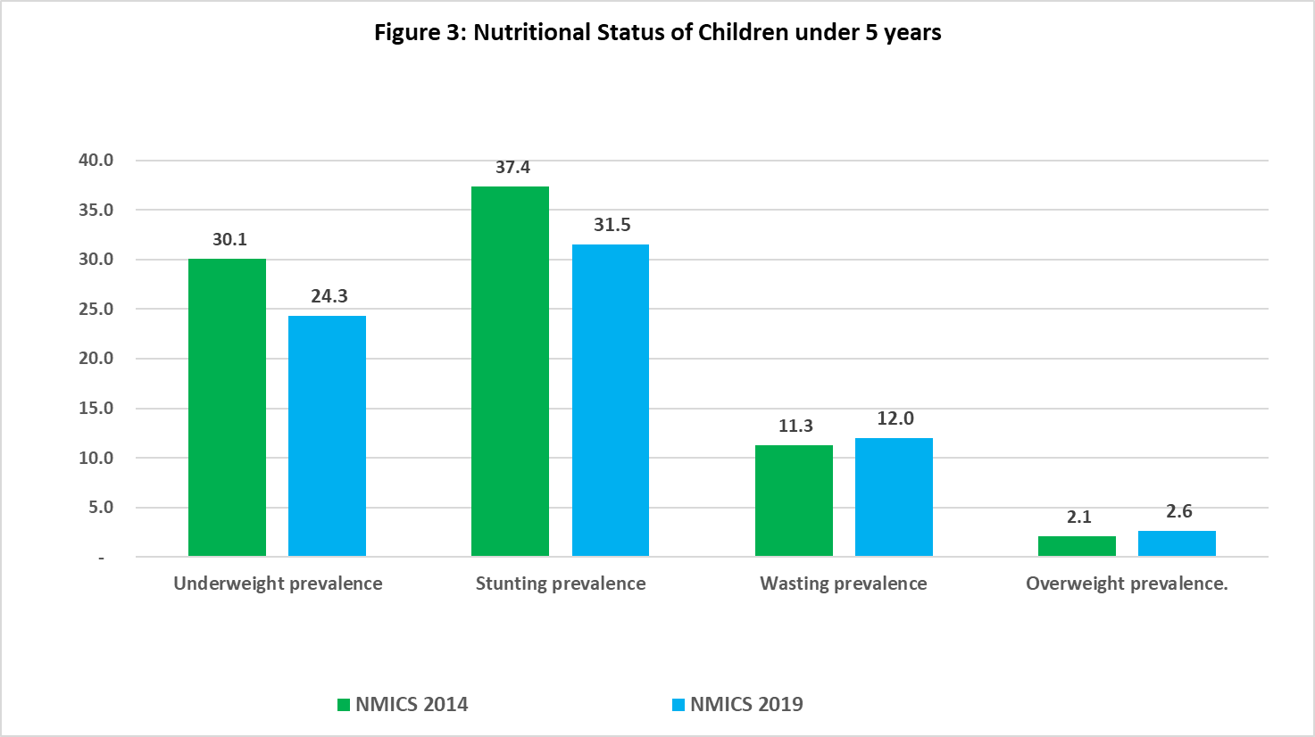In almost five years’ time, underweight and stunting prevalence amongst children under five has declined from 30.1 and 37.5 in 2014 to 24.3 and 31.5 in 2019 respectively. Children who are moderately or severely overweight and wasting in 2019 has almost remained the same in comparison to 2014. (Figure 3)
* 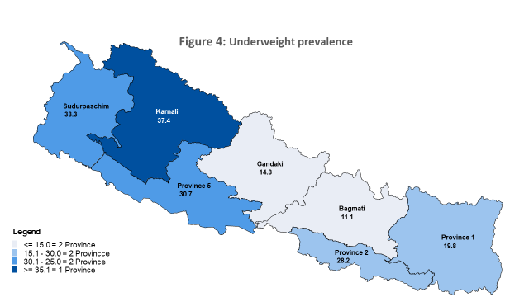Highest underweight prevalence of 37.4% has been recorded in Karnali Province followed by Sudoorpashchim Province 33.3% and Province 5, 30.7%. Lowest underweight prevalence of 11.1% is reported in Bagmati province. (Figure 4)
* In 2019, almost three out of five (62.1%) of infants under six months of age were exclusively breastfed. Of all infant under six months of age who were exclusively breastfed Province 2 reported the highest 69.9% followed by Karnali Province (68.3) and Province 5 (63.2). However, Bagmati Province 51.1 reported the lowest of them all.

* Although immunization coverage in Nepal has improved over the past five years, 70.2% of children aged 12–23 months had received all basic vaccinations by their first birthday.
* 28.9% of children under-five were treated with oral rehydration salts (ORS) and zinc.
* 61.9 aged 36–59 months were attending early childhood education programmes.
* Overall, 65.2% of children aged 36–59 months were developmentally on track according to the early child development index (ECDI).

Education

* 5.6% of children form Primary school (Grade 1-5), 4.3% of children from lower secondary school (Grade 6-8) and 15.1% of children from upper secondary school (Grade 9-12) are reported to be out-of-school.
* 39.8% of children of school-entry age reported to enter the first grade of primary school.
* 81.8 % of children from Primary school (Grade 1-5), 73.1% of children from Lower Secondary school (Grade 6-8), and 27.2% of Upper secondary school (Grade 9-12) children have reported to have completed their respective grade.

Protection from Violence and Exploitation

* Although a high proportion of mothers or caretakers of children under five (86%) know how to register a birth in Nepal, registration is still not widely practiced, with only 77.2% of births have been reported registered.
* Sudoorpashchim Province reported the highest (89.1)% of children under-five whose birth has been registered, while the lowest (70.8)% have been recorded in Bagmati Province. (Figure 5)

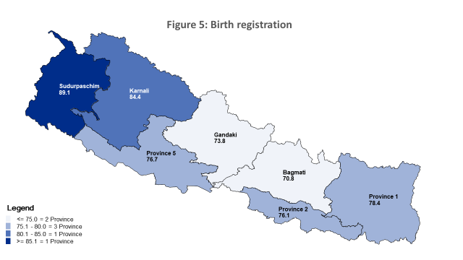

* 4.2 % of children age 0-17 years reported to have one or both biological parent’s dead. Karnali Province has reported the highest 5.7% with one or both biological parent’s dead while Bagmati Province have reported the lowest 3.2%.
* 10.6% of the children aged 2-17 years are reported to have some functional difficulties in at least one domain that includes hearing, vision, communication/comprehension, learning, mobility and emotions. (Figure 6)

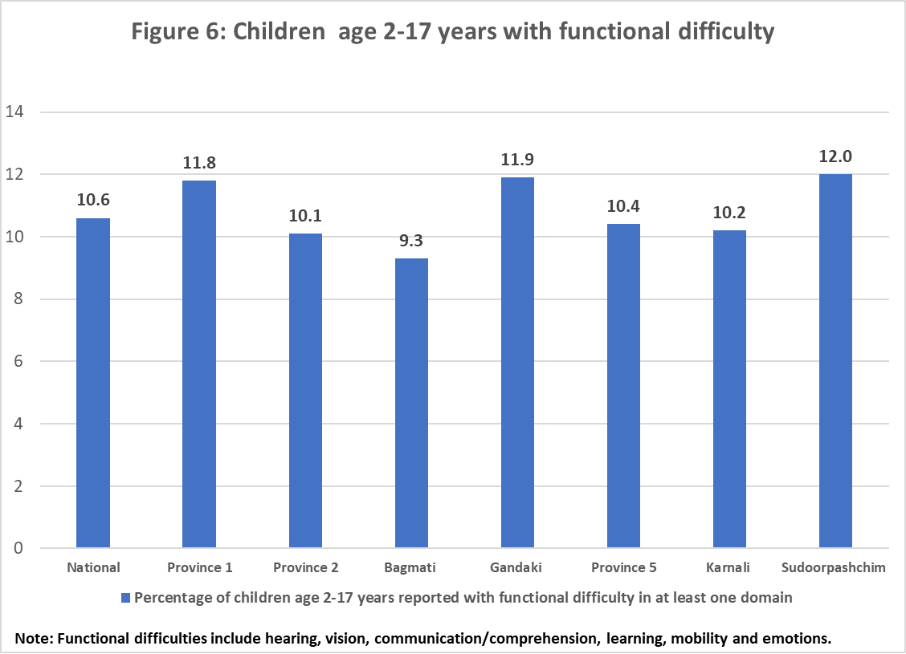

* 72.2% of women age 15-49 years reported to have heard about human trafficking as compared to 88.4% of men from the same age group.
* 19.3% of women aged 15-19 years are reported to have currently married or are in union as against 5.3% of men from the same age group.

Water, Sanitation and Hygiene (WASH)

* 97.1% of household members used drinking water from an improved water source. However, 85.1% of household members were at the risk of *E. coli* concentration in their household drinking water.
* 93.80 % of the population of Nepal is living in households using improved sanitation facilities. However, only 79.2% of the household members reported using improved sanitation facilities that are not shared.
* 80.7% of the household members reported to have handwashing facilities where water and, soap or detergent were present.

Health insurance coverage

* 5.8 % of women age 15-49 and 5.2 % of men age 15-49 have reported to have health insurance. Similarly, 4.4% of children 5-17 years and 3.7% of children under-five have reported health insurance coverage.(Figure 7)

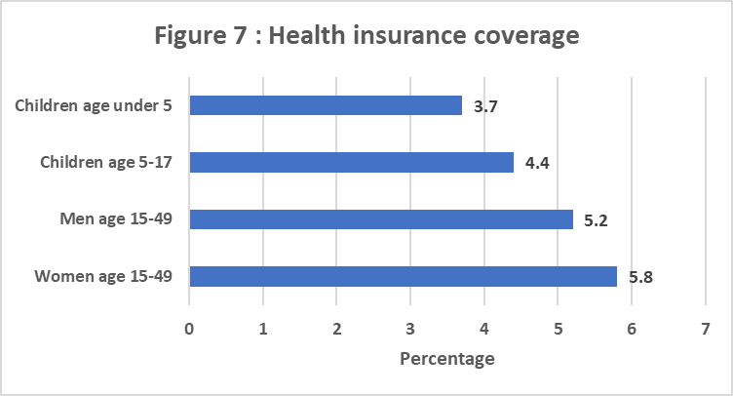

Life satisfaction

* 62.4% of women 15-49 years and 64.7% of men 15-49 years reported to be very or somewhat happy, while that remained 68.0% of women age 15-24 years and 69.6% of men reported to be very or somewhat happy.
* 45.4% women and 52.5% men aged 15-49 year have reported to have life improved during the last one year and have expected that their life will be better in another one year. Similarly 50.1 % of women and 56.4% of men aged 15-24 year have reported to have life improved during the last one year and have expected that their life will be better in another one year.

*(The Multiple Indicator Cluster Surveys (MICS) is an international household survey programme developed by UNICEF in the 1990s. Since then, close to 330 surveys have been implemented in over 115 countries. MICS is the largest source of data on the Sustainable Development Goals (SDGs) for Nepal. Since the inception of MICS globally, three rounds survey were carried in Nepal in the year 2010, 2014 and 2019*. )

**For more information:**

Central Bureau of Statistics

Gender and Social Statistics Section

Phone No. 01-4245913 /01-4245946

9841189895

9841327445

http: /www.cbs.gov.np

Thapathali, kathmandu